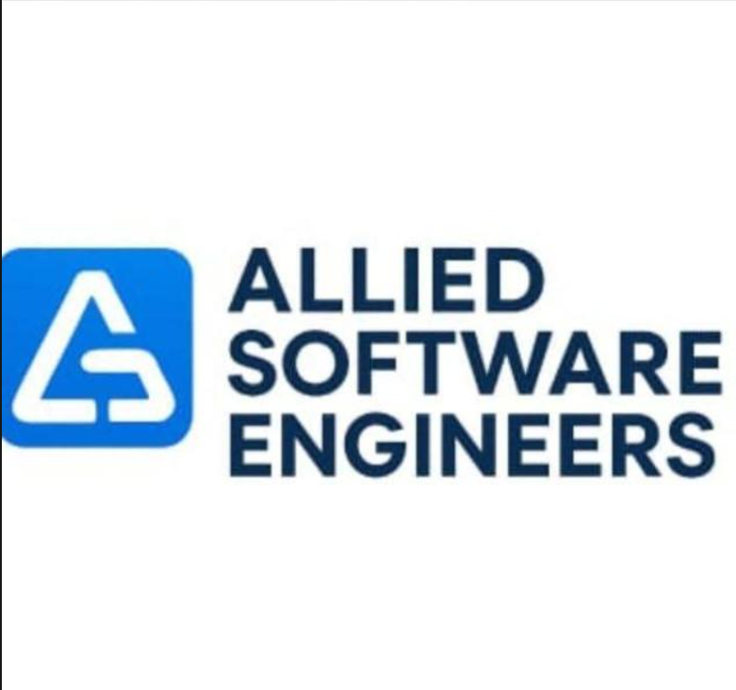

Allied Software Engineering Internship

Task 1

Name | Haroon Rasheed Qureshi
Submitted to | Muhammad Ahsan Ali
Domain | Web Development

Senario 1
Allied Software Engineers has started a new internship batch. As a MERN Developer Intern, your first responsibility is to develop the backend foundation for the Internship Registration System. The HR department wants a simple Express server that can provide basic internship information through API endpoints.
Requirements :
1. Create a folder named internship-backend.
2. Initialize a Node.js project using npm.
3. Install Express.js.
4. Create an Express server running on Port 5000.

Solution:
Server running on Port 5000
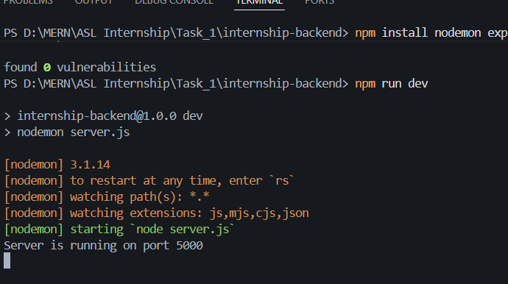

Folder Structure:
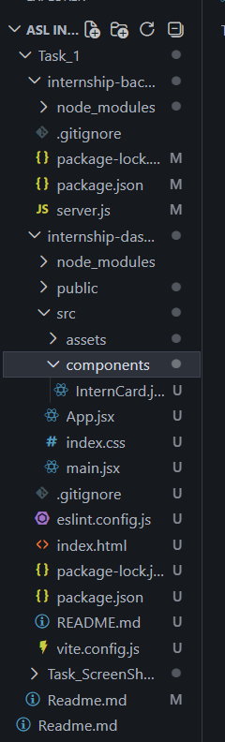
Api Endpoint working successfully
‘localhost:5000/’
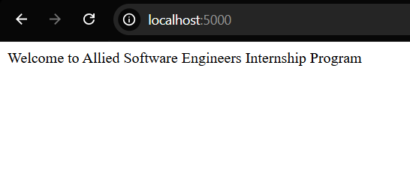
‘localhost:5000/api/tasks’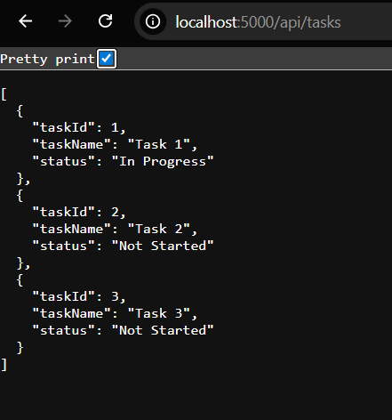

‘localhost:5000/api/interns’
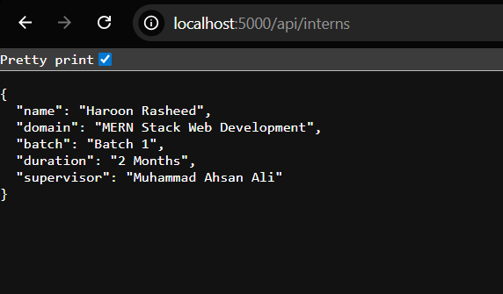

‘localhost:5000/company’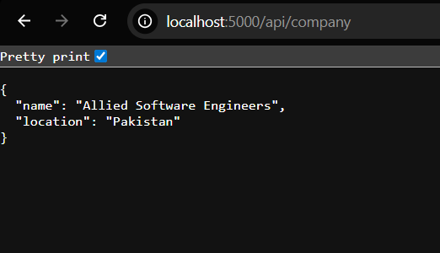

All the requirement of the senario 1 is successfully completed.
Scenario 2:
The management team now requires a simple web interface where newly enrolled interns can view their internship information. Develop the frontend using React.
Requirements
1. Create a React application named internship-dashboard.
2. Design a clean homepage.
3. Display the following information:
o Company Name
o Internship Title
o Intern Name
o Domain
o Supervisor Name
4. Create a component named InternCard.
5. Display at least three internship tasks.
6. Add a button labeled View Details.
7. Apply basic CSS styling for a professional appearance.
8. (Bonus) Fetch internship data from the backend API using Axios or Fetch API.

Solution:
Interface of the Application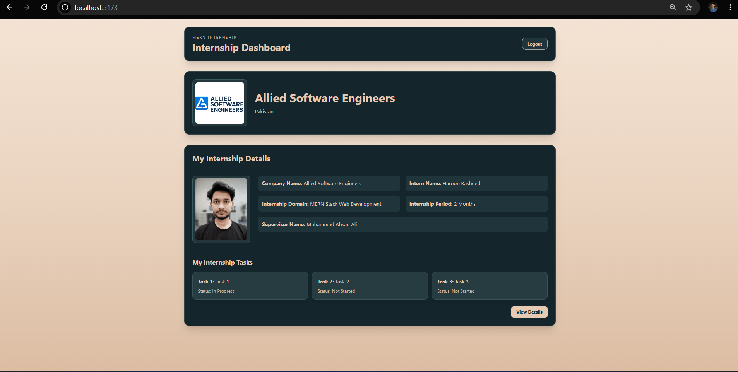

Successfully getting the data from the backend :
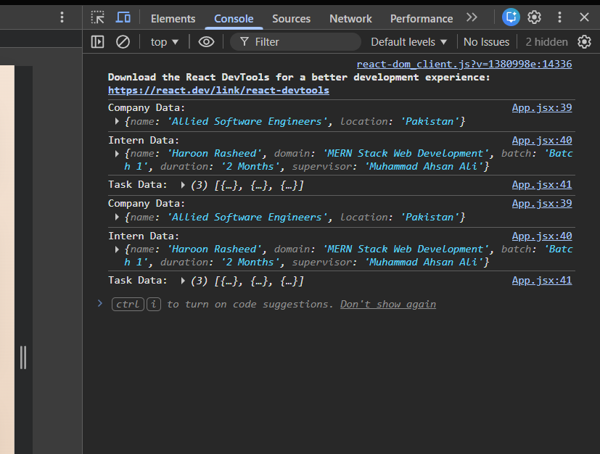
All the requirement of the senario 2 is successfully completed.

